PLEASE NOTE: IF UNABLE TO PRINT THE FILES, RESEND THEM AS ATTACHMENTS VIA EMAIL

Shop / Contact & Send-in Address
F.A.O. Nigel Eastwood - Wet Cleaning Ltd
‘Wax Jackets Cleaned’ 105-107 Buxton Road, (Old Paragon Garage)
New Mills, High Peak, Derbyshire SK22 3JT United Kingdom.
Office: 01663 74 3000 Shop: 01663 74 74 74 (24hr answerphone)
Email address: waxit@waxjacketscleaned.co.uk
www.waxjacketscleaned.co.uk / www.waxjacketscleaned.com
www.barbourrepair.co.uk

Shop Opening Hours: Monday to Friday: 8am-7pm Saturday: 8am-6pm
CLOSED ALL SUNDAYS & BANK HOLIDAYS
Please feel free to call in at our shop and drop-off your WAXED GARMENT.
Where our staff will take all your details, please download and bring the ‘OWNER SEND-IN FORM’

Cleaning & Re-Waxing Price *2018*
We have a very strict policy on > NO REPAIR ONLY – NO CLEAN ONLY – NO WAX ONLY

Clean & Re-Wax (All sizes up to & including L (large) 40”
Bomber Jacket £50.00 Jacket up to 32” (length) £50.00
Jacket / Coat above 32” (length) £55.00
Long Coat / Riding / Stockman Coat £61.00
Trousers £40.00 Gilet £42.50 Hat £15.00
Extras: Belt £3.50 - Hood £3.50 Neck Cover £3.50
Full Shoulder Guard / Cover £5.00 + any % for Size.
Extra Charges: - XL 42/44” + 10% 2XL 46/48” + 15% 3XL + 20%
Excessive / Very Dirty Jackets or Trousers Plus removal of Excessive Wax
(Extra £8.00 per item will be charged)

P & P Charges £8.00 (1 item) £12.00 (2 + Items) England / Wales Mainland
Some Scottish Post Codes + £5.00 EXTRA
N.I. and Channel Isles Min Charge of £10.00 (subject to weight)
International Postage inc. R-of-Ireland – ‘Price on Application’
All return of garment/s are Un-Insured.
If you require your garment insured extra charges will apply.
PLEASE NOTE: - WE DO NOT TAKE ANY RESPONSIBILITY FOR ANY LOSS DUE TO THE
ITEM/S BEING LOST / STOLEN OR MISS-DELIVERED BY COURIER ON RETURN.
Extra Insurance via courier can be purchased for £7.50 (Max £500.00)
Restriction plus Terms and conditions apply and does not guarantee a claim will be successful.

“Please allow up-to 6 weeks from when WjC receive your items”

Cleaning, Re-Waxing & Full Restoration Service

We Clean, Re-Wax and Repair ‘ALL’ (Vintage or Modern)
Motorbike, Country & Fashion, Any Colour or Size
Wax Cotton Jackets & Trousers
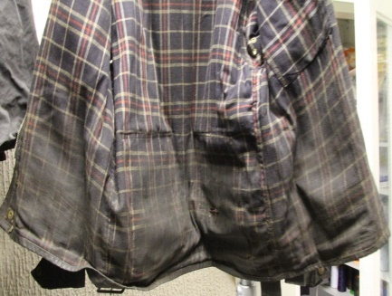
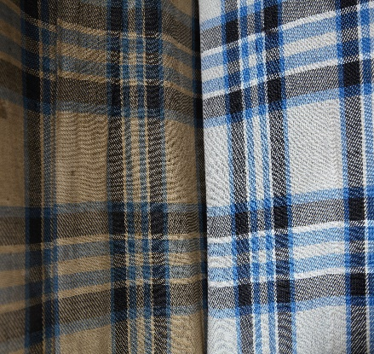
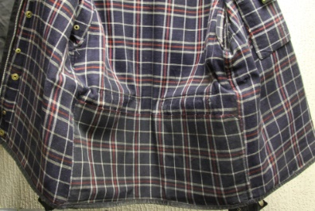
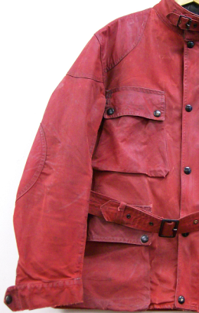
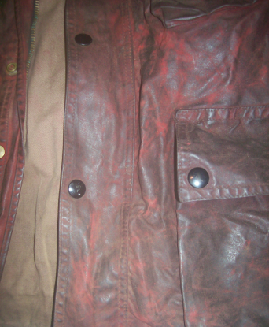

Before
After

This is what can be achieved with our unique cleaning process and
will remove up to 99% of any bad smells associated with wax cotton garments, ‘Yes’ these are the same jackets.

Please also be aware that not all stains can be removed, there are limitations with the gentle cleaning process but we endeavour to achieve the best result possible without damaging the garment, most come perfectly clean, but it will be clean and most important ‘FULLY WEARABLE’.

We carry out a full and comprehensive repair, alteration and modification service to all
Wax Cotton Garments.
PLEASE NOTE: we DO NOT give estimates or quotations over the telephone, we only quote once
we have seen the garment, if you want to send some pictures we can hopefully give a rough
estimate for the works, please email us – waxit@waxjacketscleaned.co.uk

MINIMUM CHARGE FOR REPAIRS - £10.00

We DO NOT Guarantee that your Jacket or Trousers Waterproof or 100% Waterproof
But please say how you will use the jacket as we will then endeavour to get as close as possible.
NO ‘new’ WAXED COTTON IS GUARANTEED 100%WATER-PROOF

Some can and will change colour slightly and some dramatically, wax dressing is a Neutral colour and have no dyes,
special finishes on modern Wax Cotton Garments can never be replicated.
Wax Jackets are an outdoor item of clothing, after the Cleaning & Re-waxing it is advisable NOT to wear indoors and in Motor Vehicles
as the wax dressing will transfer on to other fabrics.
After the process some have a more of a stickier finish than others, please see below for more details, but this will settle down after a sort time of wearing.
Your item will ‘NOT’ come back NEW it will be returned Cleaned and Professionally Re-Waxed by hand.
Cleaned means we will get it as clean as possible, it is a gentle cleaning process so there are limitations,
in 95% + of cases we get them perfectly clean, some stains may still be visible!! But the garment will be clean and more importantly fully wearable.
In sending your garment/s for Cleaning / Repair / Alteration & Re-waxing, you are giving authority for Wax Jackets Cleaned to
complete the necessary works and agree to all WjC Terms & Conditions

‘Important Information about the Wax Finishes / Dressings Available’

Silk-oil Wax Finish (WAX 2) – EXTRA charge of £5.00 + any % for size
This finish the most popular does have little sticky finish / touch, but this does settle down after a few weeks and is ideal for more outdoor use, it gives a very good water-resistant finish. This wax is supplied direct from a UK manufacturer of waxed cotton fabric and regularly used.

Heavy Wax Finish (WAX 3) - EXTRA charge of £10.00 + any % for size
This finish can be very sticky and has an oily touch; this will give as close to WATER-PROOF (but not Guaranteed) that’s possible, not advisable to be worn as other than OUTDOOR clothing, ideal for Riding Coats and full-length Stockman’s where not used for casual / fashion use.

Basic / Fashion Wax Finish (WAX 1)
This is a basic wax dressing and has little or no sticky oily touch finish, ideal for the modern wax cotton Jacket / Garment getting increasingly popular.

Important Information
Please send your Garments via a signed - for service.
(Royal Mail Signed for service is ample)
We must be able to sign for the Garment/s at our shop.
(No signature!! NO proof of Delivery)
We can’t be responsible for garments lost in post.
CHECK ALL POCKETS BEFORE SENDING

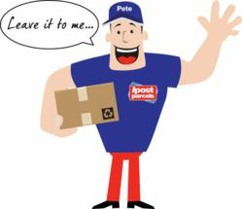
*** WHY NOT TRY ***
www.ipostparcels.com

Try this service it is fully tracked, Next Day Service and Collected from you.
And in most cases CHEAPER than Royal Mail.

ALL Wax Jackets SAY *DO NOT* *DO NOT* *DO NOT*
Most manufactures would prefer you to buy a NEW one, that’s not very eco-friendly and cost effective but here at WjC we have the solution 😊.

